**Unit 2: Using Objects**

**Topic 8: Using the Math Class**

|  |  |
| --- | --- |
| **Name:** |  |

**Create a new IntelliJ project for today, LASTNAMEU2T9Lab, or something like that.**

|  |  |
| --- | --- |
| Circles! | |
| Here is an incomplete Circle class:  public class Circle  {  private double radius;  public Circle(double radius)  {  this.radius = radius;  }  /* Returns the area of the circle with given radius  Area of a circle = pi * r ^ 2  **Use Math.PI for pi** and use the **pow** method  */  public double area()  { **/* implement this method! */** }  /* Returns the circumference of the circle with given radius  Circumference of a circle = pi * 2 * r  **Use Math.PI for pi**  */  public double circumference()  { **/* implement this method! */** }  /* Setter method to update the radius of the circle to newRadius  */  public void setRadius(double newRadius)  { **/* implement this method! */** }  /* Returns a String that includes info about the circle,  including its radius, area, and circumference *on separate lines;*  see example output below (**Reminder**: the new line escape  sequence \n allows you to include new lines in Strings!)  ***Note that this method should return a string*** -- it should **NOT**  do any printing. This method should call your *other* methods!  */  public String getInfo()  { **/* implement this method! */** } **Hint for getInfo** }  **1.** Complete the Circle class above by completing the three missing methods in IntelliJ.!  **2. TEST** your methods by creating a client/runner class and writing test code to do the following:   * Create a new Circle object with a radius of 5.0 * Print out the string returned by the getInfo() method * *Set* the radius of the circle to a *new* value of 9.2 * Print out the string returned by the getInfo() method again, noticing that all the values reflect the updated radius value   ***If you wrote your methods and test cases correctly, you should see:***   Let me check my test code **3.** Write *a second* test case of your own.  **4.** Once you have everything running correctly, copy/paste your code below: | |
| The test code you wrote in steps 2 & 3 above: | |
| Your completed code for the Circle class: *Compare* | |
| Sam wrote the following code to calculate 6.5 raised to the third power and print the result:  double x = 6.5;  double thirdPower = (x ^ 3);  System.out.println(thirdPower);  Will this code calculate and print what Sam was hoping? If not, help Sammy **fix** his code so that it does! | *Confirm* |

**Lab continues on next page**

|  |
| --- |
| Right Triangles! |
| 1. Create a new RightTriangle class.    1. The class should have two instance variables, base and height, both of type double.    2. Add a constructor that takes in both base and height as parameters and initializes the instance variables to those values.    3. Add a hypotenuse method that has no parameters and returns a double. This method should return the length of the hypotenuse using the Pythagorean Theorem:   *a*2 + *b*2 = *c*2, where *a* is base and *b* is height. Use $c =\sqrt{a^{2}+b^{2}}$ to find *c*, the hypotenuse, which gets returned by the method. Let me confirm the instance variables and constructor  1. **TEST** your class and hypotenuse method by writing test code to do the following:    * Create *two* new RightTriangle objects, one with a base = 3 and height = 4, and the other with a base = 6.5 and height = 10.7    * Store the length of each triangle’s hypotenuse in its own variable (use the hypotenuse method).    * Print each variable to confirm the hypotenuse lengths match the expected output below.   ***If you wrote your methods and test cases correctly, you should see:***   Let me check my test code **3.** Write *a second* test case of your own.  **4.** Once you have everything running correctly, copy/paste your code below: |
| The test code you wrote in steps 2 & 3 above: |
| Your completed code for the RightTriangle class, including the hypotenuse method: *Compare* |

**Exploration continues on next page**

|  |  |
| --- | --- |
| RaNdOM nUmBErS | |
| **From the AP Exam Java Reference Sheet:**    **Math.random() takes no parameters and returns a double value *greater than or equal* to 0.0 and *strictly less than* 1.0. In other words, exactly 0.0 *is* possible, but exactly 1.0 is *not* -- although 0.9999… is**   |  | | --- | | **Free Style!** Write some code to use the random() method a few times and print the results (you should see that it produces a different random decimal each time it is called). | | Copy/paste the code you wrote: | | Can you figure out how to use the random()method to generate a random number between 1.0 and 10.0 (*excluding* exactly 10.0)?  *See if you can work this out* ***before*** *reading below:* | |  |   **Below are examples of how to generate a random double within a certain range:**  **// RANGES OF DOUBLES**  **// Ex 1: generate a random double between 0.0 and 1.0 (excluding exactly 1.0)**  double randomNum = Math.random();  **// Ex 2: generate a random double between 0.0 and 10.0 (excluding exactly 10.0)**  double randomNum = Math.random() * 10;  **// Ex 3: generate a random double between 0.0 and 20.0 (excluding exactly 20.0)**  double randomNum = Math.random() * 20;  **// Ex 4: generate a random double between 5.0 and 20.0 (excluding exactly 20.0)**  double randomNum = Math.random() * 15 + 5;  **// Ex 5: generate a random double between 8.0 and 35.0 (excluding exactly 35.0)**  double randomNum = Math.random() * 27 + 8;  **// Ex 6: generate a random double between 15.0 and 60.0 (excluding exactly 60.0)**  double randomNum = Math.random() * 45 + 15;   |  | | --- | | **Revisit your answer to the previous question; after seeing the 5 examples above, modify your answer (if needed, otherwise leave blank!):** | | Using the examples above, figure out how to write an expression to generate a random double between 25.0 and 100.0, *exclusive* of 100.0. | | Confirm |   **// RANGES OF INTS**  **note the use of (int) casting AFTER the multiplication takes place!**  **// Example 6: generate a random int between 0 and 9, *inclusive* (including 9)**  int randomNum = (int) (Math.random() * 10);  **// Example 7: generate a random int between 1 and 10, *inclusive* (including 10)**  int randomNum = (int) (Math.random() * 10) + 1;  **// Example 8: generate a random int between 5 and 10, *inclusive* (including 10)**  int randomNum = (int) (Math.random() * 6) + 5;  **// Example 9: generate a random int between 8 and 20, *inclusive* (including 20)**  int randomNum = (int) (Math.random() * 13) + 8;  **// Example 10: generate a random int between 75 and 99, *inclusive* (including 99)**  int randomNum = (int) (Math.random() * 25) + 75; | |
| **Study the examples above; focus on 6 - 10 which are used to produce a random *integer* (the most common use!)**  What *relationship* do you notice between the desired random range (e.g. “between 8 and 20”) and the numbers used to produce the random number? |  |
| When you think you have the relationship figured out, complete the line of code below to generate and store a random integer from 50 to 85, *inclusive*, in randomNum: | |
| int randomNum = | |
| **TEST!** We haven’t formally discussed **iteration** (loops) yet, but below is a for loop in Java that you can use to help test to see if your expression produces a random number in the desired random range. Copy/paste the code below in your IDE, replacing your code above in the space:  for (int i = 0; i < 100; i++) {  int randomNum = **/* put your code here to generate a random number between 50 and 85 */**  System.out.println(randomNum);  }  This will loop **100** times, printing a random integer each time; it’s not a perfect way to test randomness, because you can’t ever guarantee certain numbers will get selected, but it’s a decent way to get a feel for the types of numbers your code produces.  You should be looking to make sure:   * **50** is the ***lowest*** possible number that ***ever*** shows up * **85** is the ***highest*** possible number that ***ever*** shows up * All other values fall between these   With 100 loops, you have a pretty good chance of seeing both “border” numbers (50 and 85); if not, just run it again until you do! Feel free to change 100 to another number, or change up how the printing is formatted. → After testing your code with the loop, ***confirm the relationship & code*** ***←*** **After checking the answer above, choose which "version" of the formula you like best (A and B or min and max), and type it below:**   |  | | --- | |  |   **This is a super important formula that you need to memorize!** | |
| **Now use your formula to write the expressions below:** | |
| Generate and store a random integer from 0 to 6, *inclusive*, in randomNum: | |
| int randomNum = | |
| Generate and store a random integer from 1 to 6, *inclusive*, in randomNum: | |
| int randomNum = | |
| Generate and store a random integer from 25 to 30, *inclusive*, in randomNum: | |
| int randomNum = | |
| Generate and store a random integer from 100 to 200, *inclusive*, in randomNum: | |
| int randomNum = | |
| Generate and store a random integer from 94 to 132, *inclusive*, in randomNum: | |
| int randomNum = | |
| Generate and store a random integer from 1 to 999, *inclusive*, in randomNum: | |
| int randomNum = | |
| Generate and store a random integer from -15 to 50, *inclusive*, in randomNum: | |
| int randomNum = | |
| *Confirm your answers* | |

|  |  |
| --- | --- |
| Below are two lines of code that are intended to generate and print two random integers between 2 and 10, inclusive of 10.  Will they both work? If not, why not?  *If you aren’t sure, copy/paste and run the code several times in IntelliJ* ***before*** *you answer!*  int rand1 = (int) (Math.random() * 9) + 2;  int rand2 = (int) Math.random() * 9 + 2;  System.out.println(rand1);  System.out.println(rand2); | check |

|  |
| --- |
| **Lucky Numbers!** |
| Below is an incomplete LuckyNumbers class:  public class LuckyNumbers  {  /* No instance variables */  /* "empty" constructor with no parameters */  public LuckyNumbers() { }  /* Generates a random number between min and max, *inclusive*,  and returns that random number  */  public int randomIntegerBetween(int min, int max) {  **/* implement this method! */**  }  /* Generates and **returns a String** containing lucky numbers!  For this lucky number game, there are 5 balls randomly drawn,  each between 1 and 65, and one "super ball" between 1 and 30.    In this game, the same number **CAN** appear more than once.  The returned String should have the 6 numbers listed (they do not  need to be in ascending order): 5 "lucky numbers" between 1 and 65,  and the last one, the "super ball," between 1 and 30.  **See samples below.**  **This method should call your randomIntegerBetween method above multiple times --**  **don't rewrite the same code over and over to generate multiple random numbers,**  **use your method!**  */  public String getLuckyNumbers() {  **/* implement this method! */**  }  }  **1.** Implement the LuckyNumbers class above in IntelliJ by completing the two missing methods. ***Please be sure to read both method descriptions carefully!***  **2. TEST** your class and methods by writing test code to do the following:   * Create a LuckyNumbers object (using the default, no argument constructor). * Call the getLuckyNumbers method and store the returned String in a variable. * Print the variable to make sure it looks something like the following:   ***If you wrote your methods and test code correctly, you should see:***    ***Run again, it produces new lucky numbers!***   Let me check my test code  **Note!** *Each “lucky number” should be between 1 and 65, and the “super ball” should be between 1 and 30.* |
| Copy/paste your code for your tested and completed LuckyNumbers class below: *Compare* |

**Lab concludes on the next page!**

|  |  |
| --- | --- |
| Exploring the Math Class | |
| Locate and explore the [Java API docs](https://docs.oracle.com/javase/8/docs/api/) for the Math class (it’s part of the **java.lang** package, along with String and System). Scroll to and click on the Math class in the bottom left.  Find **one or two** other static methods that sound interesting to you and click on them to learn more!    **Here are a few that you might want to check out:**   * Trigonometry methods: Math.sin(), Math.cos(), Math.tan() * Conversion methods: Math.toDegrees(), Math.toRadians() * Other math methods: Math.round(), Math.floor(), Math.ceil() * Max/min methods: Math.max(), Math.min()     **NOTE!**  *Only* the five Math methods listed on the Java Quick Reference are tested on the AP Exam, so whatever method(s) you explore now are *bonus!* But as a software engineer, you should be familiar with using documentation to learn what functionality is available to you!  **Write some code to test out the method(s) you explored.** | |
| Which Math method(s) did you learn about? |  |
| Copy/paste the code you wrote to test out the new method(s): | |

**Done!**

Submit in Google Classroom



### Sample Solution (back)

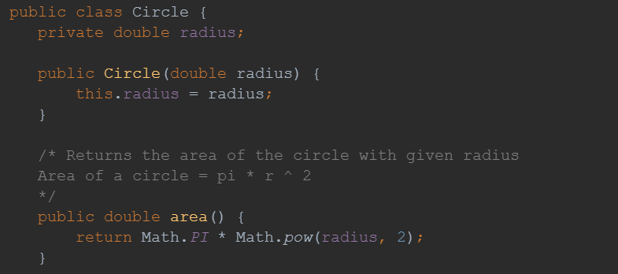

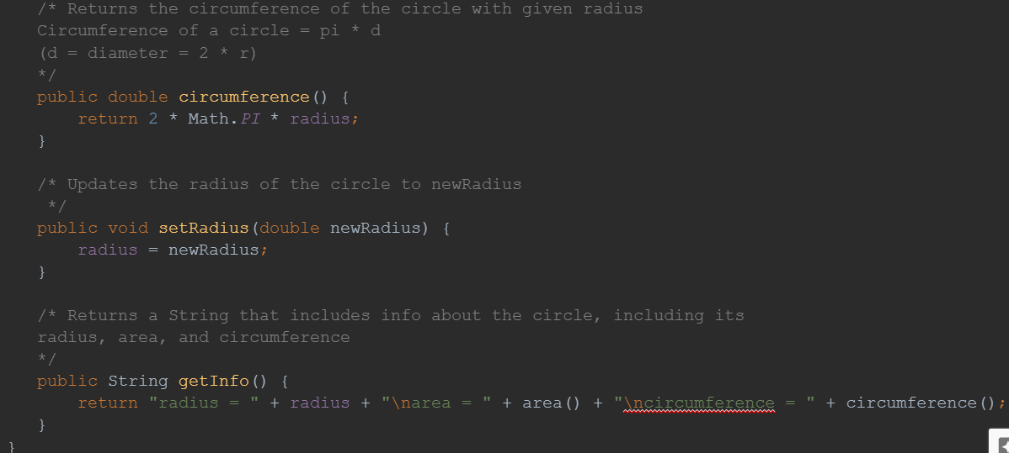

### Solution (back)

The **^** is **NOT** how you do exponents in Java! This is actually a totally different thing in Java (look up "caret operator Java" if you're curious what it does, although you don't need to know it for this class).

double x = 6.5;

double thirdPower = (x **^** 3); **// does NOT do exponentiation!!!**

System.out.println(thirdPower);

This is how Sammy can fix his code:

double x = 6.5;

double thirdPower = **Math.pow(x, 3)**;

System.out.println(thirdPower);

**Note: it should print out: 274.625**

### Sample Solution (back)

**Below is one possible solution for the hypotenuse method:**

In this case, “hypotenuse” is side *c* in this equation: $c =\sqrt{a^{2}+b^{2}}$

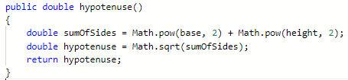

**OR** you could return the square root directly:

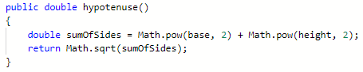

**Your complete class should look something like:**

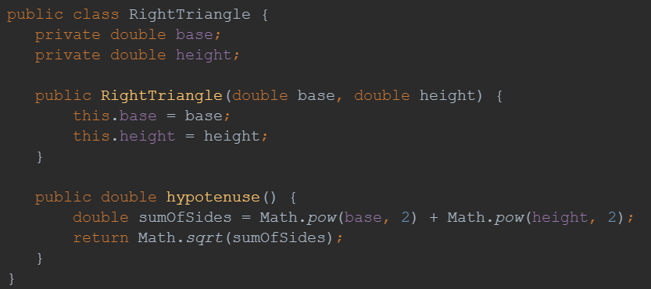

### Solution (back)

**Relationship:**

To generate a random **int** between **A** and **B**, inclusive (*including* **B**)

**randomNum = (int) (Math.random() * (B - A + 1)) + A;**

Alternatively, referring to A as **min** and B as **max**:

**randomNum = (int) (Math.random() * (max - min + 1)) + min;**

So the code you can use to generate a random integer between **50 and 85**, inclusive is:

randomNum = (int) (Math.random() * (**85 - 50 + 1**)) + **50**;

**Or more simply:** randomNum = (int) (Math.random() * **36**) + **50**;

### Solutions (back)

**//Generate a random int between A and B, inclusive (including B)**

**randomNum = (int) (Math.random() * (max - min + 1)) + min;**

|  |
| --- |
| Generate and store a random integer from 0 to 6, *inclusive*, in randomNum: |
| int randomNum = (int) (Math.random() * 7) + 0 **→** **(int) (Math.random() * 7)** |
| Generate and store a random integer from 1 to 6, *inclusive*, in randomNum: |
| int randomNum = (int) (Math.random() * 6) + 1 |
| Generate and store a random integer from 25 to 30, *inclusive*, in randomNum: |
| int randomNum = (int) (Math.random() * 6) + 25; |
| Generate and store a random integer from 100 to 200, *inclusive*, in randomNum: |
| int randomNum = (int) (Math.random() * 101) + 100; |
| Generate and store a random integer from 94 to 132, *inclusive*, in randomNum: |
| int randomNum = (int) (Math.random() * 39) + 94; |
| Generate and store a random integer from 1 to 999, *inclusive*, in randomNum: |
| int randomNum = (int) (Math.random() * 999) + 1; |
| Generate and store a random integer from -15 to 50, *inclusive*, in randomNum: |
| int randomNum = (int) (Math.random() * 66) - 15; |

### Solution (back)

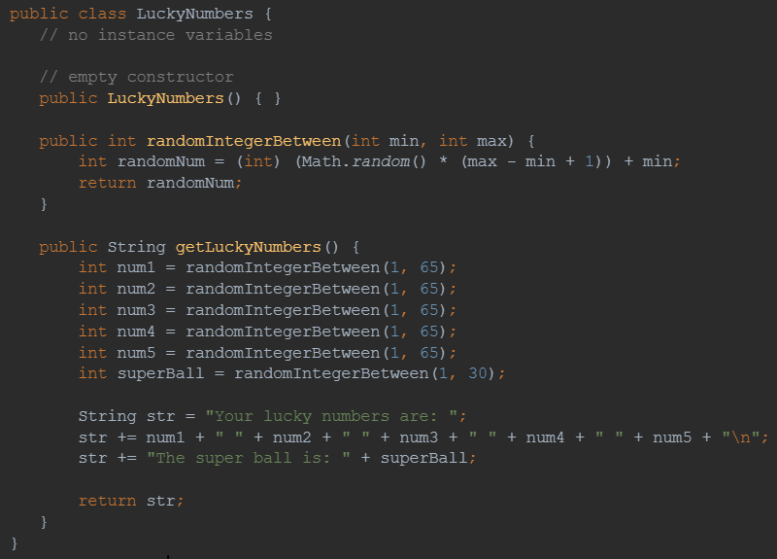

### 

### Test Code (back)

**This is the test code that produces the output shown:**

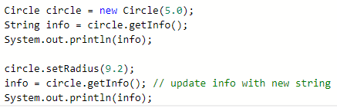

**Note that you didn’t need to store the info string as a variable first, you could have just printed it directly like this:**

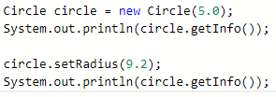

### Confirm (back)

Here is how the instance variables and constructor should be set up:

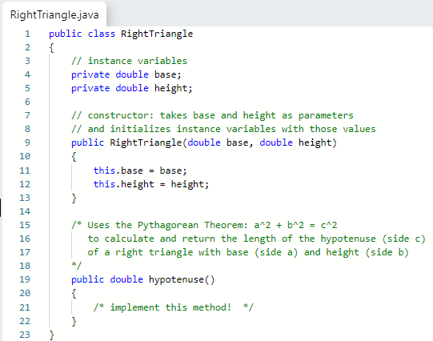

### Confirm (back)

|  |
| --- |
| Revisit your answer to the previous question; after seeing the 5 examples above, modify your answer (if needed, otherwise leave blank!):  **Math.random() * 9 + 1** |
| Using the examples above, figure out how to write an expression to generate a random double between 25.0 and 100.0, *exclusive* of 100.0. |
| **Math.random() * 75 + 25** |

### Test Code (back)

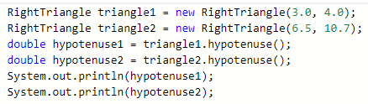

### Test Code (back)

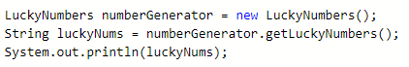

### Hint (back)

This code:

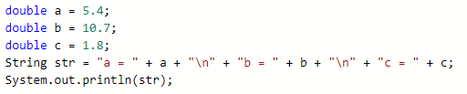

WIll produce a string where a, b, and c are separated by new lines:



### Answer (back)

|  |  |
| --- | --- |
| Below are two lines of code that are intended to generate two random integers between 2 and 10, inclusive of 10.  Will they both work? If not, why not?  *If you aren’t sure, run them in IntelliJ before you answer!*  int rand1 = (int) (Math.random() * 9) + 2;  int rand2 = (int) Math.random() * 9 + 2;  System.out.println(rand1);  System.out.println(rand2); | They will **NOT** both work!  The **first line is correct** and rand1 will be a correctly generated random number  The **second is not correct** as it will **ALWAYS PRODUCE 2, every time!** This is because the (int)casting happens on the Math.random() result ***before*** multiplying by 9, and since Math.random() returns a value less than 1.0, it will *always* truncate to 0 when cast to an int, and *then* 0 * 9 is 0, and finally 0 + 2 is 2, so rand2 *will* ***always*** *be 2 -- NOT a random number!*  **Oh, the importance of parentheses!** |